Rotary Club of Kathmandu Mid-Town
Breakfast Chatter
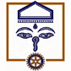



2 March 2012 The Weekly Bulletin of Rotary Club of Kathmandu Mid-Town Bc-3.02/011-12

District: 3292 Web: www.rotarymidtown.org.np Club Id : 26776

MARCH IS LITERACY MONTH
Teach children the value of life, and that they should respect others, no matter what sex or caste they belong to. If you can change their way of thinking, and introduce them to a better way of life,
you will be doing them and the entire community a great service.

24 February, Friday:
Dr Franz Josef Radermacher, Director, FAW/n, Ulm, Germany who was in the Capital to address ICM on Peace and World Understanding as the key-note speaker, was our guest speaker.
Dr Radernacher is Director of The Research Institute for Applied Knowledge Processing/n (FAW/n), a non-profit foundation governed by public law. The foundation’s work is based on research and development in the field of application-oriented knowledge processing. Its wider topics are globalisation, global governance, sustainable development, population development, intercultural dialogue, environmental protection, social issues, the function and structure of markets, the central role of education, global trade and the global financial system, and the worldwide information and knowledge society. All the activities of the FAW/n are based on scientific research at the interface of various scientific disciplines and cross-linked with others via thematic networks in different areas of expertise.
Dr Radermacher briefly threw lights on innovation, rapid development and changes in technology and its impact in economic and social management, and future challenges.
.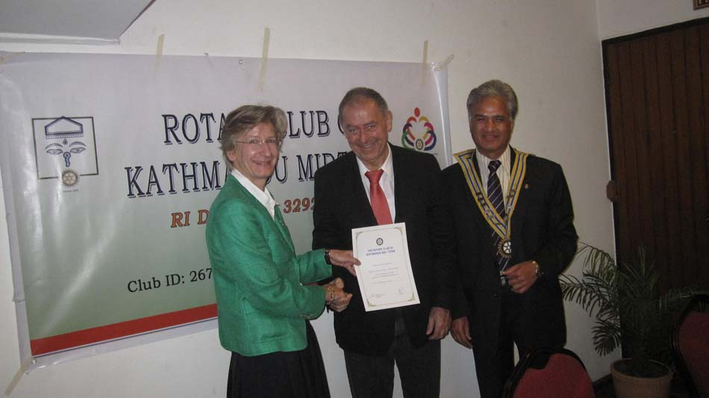
Ambassador Rtn Verena presenting certificate of appreciation to Guest Speaker
Prof Dr Franz Josef Radermacher while President Som looks on

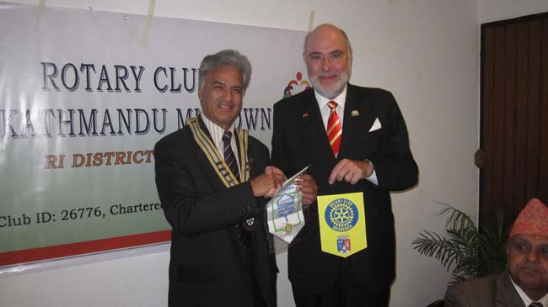
President Som exchanging club flag with a visiting Rotarian from a German Club

Weekly Meetings and Programs :
Date | Program/Speaker | Program/Topics of Presentation
2 March 2012 | Dr Niti Rana | The Phenomenon of school bullying
9 March 2012 | Rtr Samir Nepal | Rotaract/Rotary Collaborations: 2011/12 achievements
16 March 2012 | Mr Prashanta Singh | Himalayan Climate Initiatives: Success and Challenges

Feuerwehrprojekt Kathmandu-Lagebericht
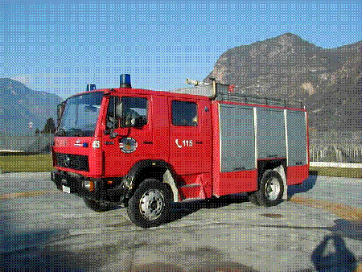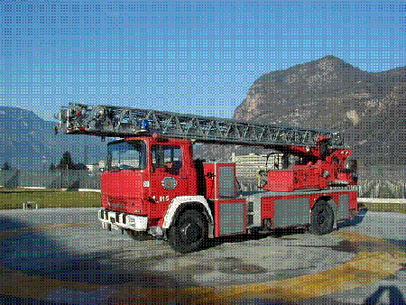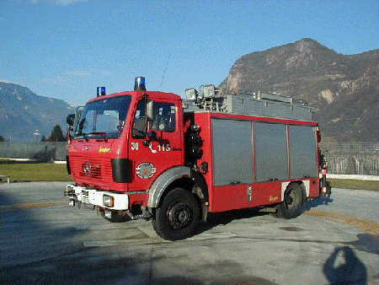
Fire Truck 2000l (1995) Aerial Ladder Basket Magirus (1980) Heavy Rescue Truck
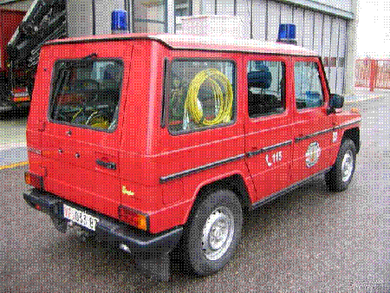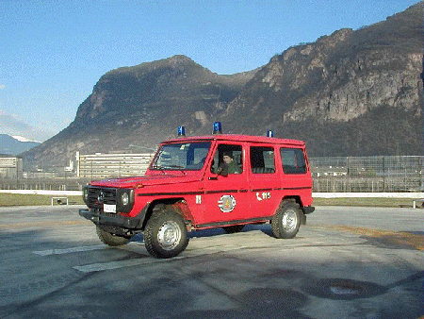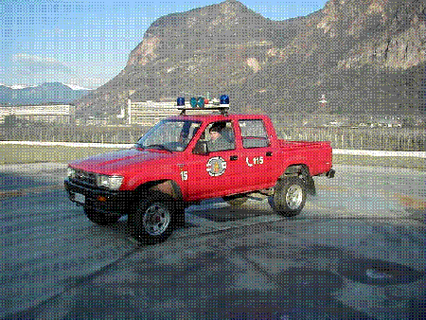
Small Rescue Truck 3 man crew Car for personnel transport Pick up Toyota (1993)
The fire-fighting equipments - fire truck, aerial ladder, rescue trucks, pick up and personnel transport car as shown in the above pictures and other fire-fighting materials such as pumps, power generator, protective clothes, hydraulic spreader etc, donated by Autonomous Province of BOLZANO/Bozen – Professional Fire Brigade to KMC Firebrigade, Kathmandu, are scheduled to be shipped in beginning of March 2012. They are being shipped in three containers. It will take two-three months to reach destination port. The consignment is expected to reach Kathmandu around end of May, or beginning of June 2012.
Source: Rtn Navyo Eller

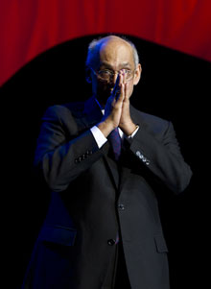
When we in Rotary work for peace, we don’t do it by negotiating treaties or demonstrating in
the streets. Instead, we build peace by example – by working together, whatever our
nationality or background, and putting others’ needs above our own.
RI President Kalyan Banerjee

On Lighter Side : Click here ⇩


A thought for the day:
Never play with the feelings of others, because you may win the game.
But the risk is that you will surely lose the person for a life time.
- Shakespeare

A white revolution is in the offing:
Although dairy farming has been in practice in Nepal for centuries, it used to be a family business meant only for domestic consumption. The growing demand of dairy products, especially milk, in ever-growing urban centers, attracted investment and a group of young entrepreneurs established Lumbini Agroproducts to realize dream and vision of white revolution. Everything is mechanized on the farm. Machine does the works ranging from grass sowing to cutting and from preparing fodder to milking. Located at Tikuligarh of Rupandehi district, the LA has an ambitious plan of producing at least 3,000 ltrs of milk every day with 600 holstein and jersey cows and dozens of hybrid buffaloes.
Source: Yuba Nath Lamsal/The Rising Nepal

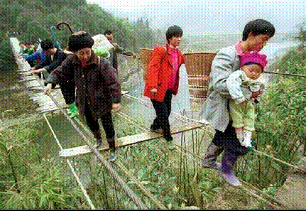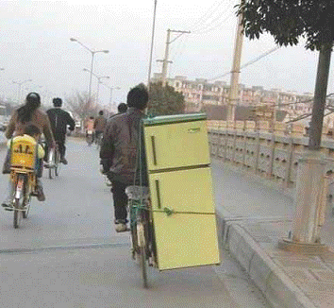
Need to go across the river anyway ! What a balance !

Please send project/activity information, suggestions and photos etc to :
BC Editor: RR Shrestha email: rryes@wlink.com.np

2 March 2012 The Weekly Bulletin of Rotary Club of Kathmandu Mid-Town bc-3.02/011-12

